**Name -Monika Gariya**

**Email-** [**monikagariya2023@gmail.com**](mailto:monikagariya2023@gmail.com)

**Data Engineering Batch 1**

**Date – 23-02-2024**

**TOPIC – Setting up DevOps repository and pushing and pulling the file.**

**Working with Azure Repos**

From here, we could invite others to work on the project if needed.  Project settings are still accessible from the link in the lower left corner.  But we still have a blank slate.  Let’s start with the Repos service.  We can click the button on the welcome screen or select Repos from the left-hand menu.

**Git Push Command**

The **git push command uploads content from a local repository to a remote repository**. Pushing refers to the process of moving commits from one repository to another. Pushing is the equivalent of git fetch, except that instead of importing commits to a local branch, it exports commits to an external branch.

The Git push command is used to push the local repository content to a remote repository. After a local repository has been modified, a push is executed to share the modifications with remote team members. Pushing is the way commits are transferred from the local repository to the remote repository.

The folder "FirstRepo" is empty. We will now initialize a repository to our folder. Something called the "master" appears on the screen. Whenever a Git repository is created for the first time, it creates a branch, and the name of the branch is master. Navigate to the folder; you can find a hidden ".git" folder. If you check the folder, you can see several directories and configurations. Make sure you don't make any changes to any of the directories.

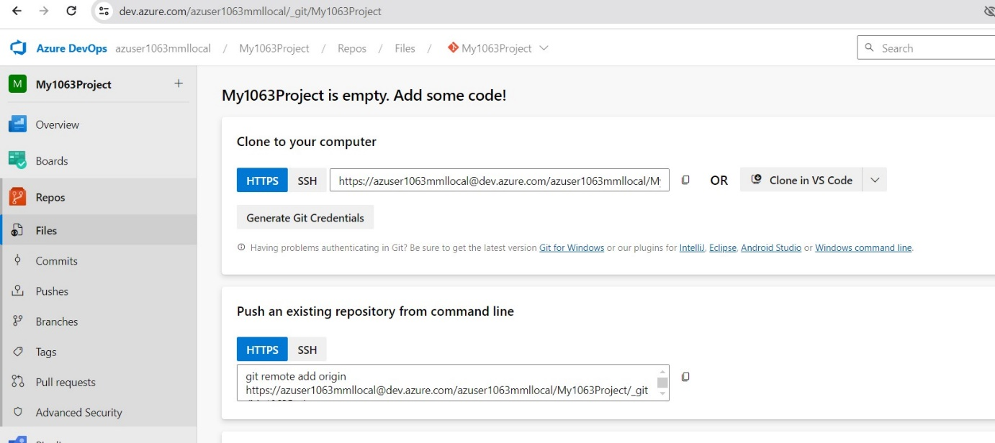

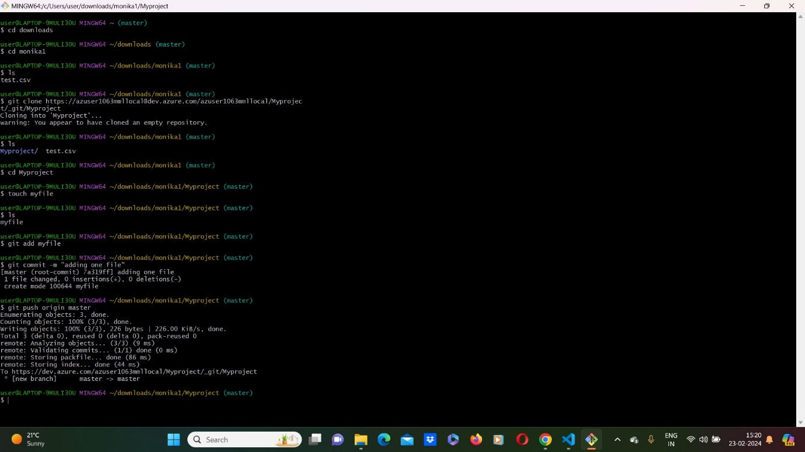

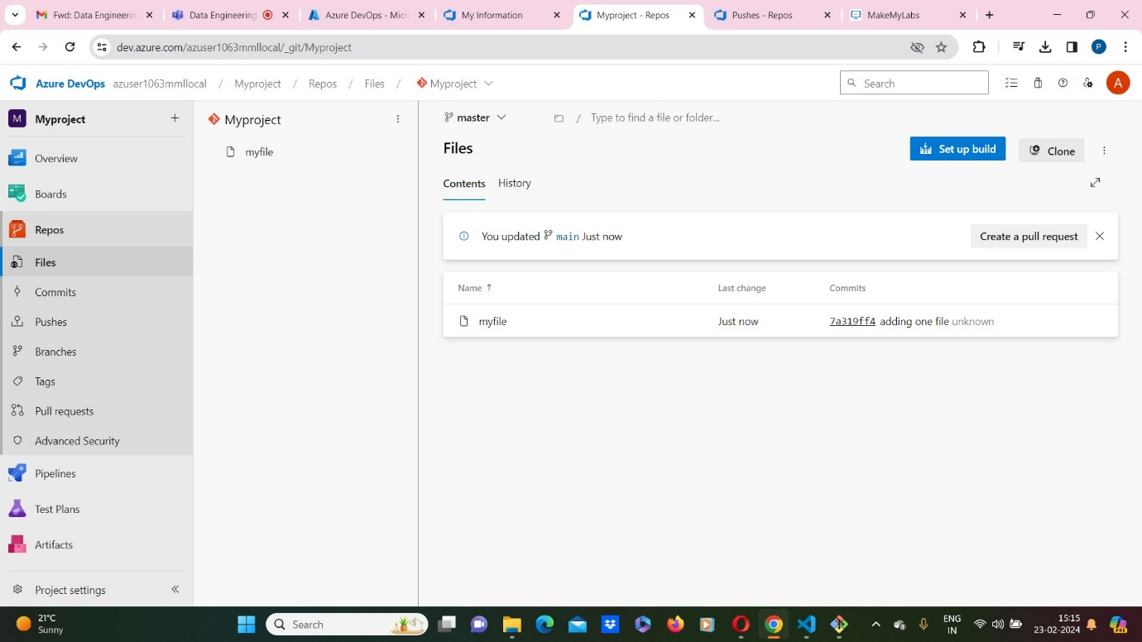

**Clone with vs code**

